1] (A)
#include <stdio.h>
void selectionSort(int a[], int n){
for(int i=0;i<n-1;i++){ // i = index where next minimum should go
int minIdx = i; // assume element at i is minimum
for(int j=i+1;j<n;j++){ // find actual minimum in a[i+1..n-1]
if(a[j]<a[minIdx]) minIdx = j;
}
// swap
if(minIdx != i){
int t = a[i]; a[i] = a[minIdx]; a[minIdx] = t;
}
}
}
int main(){
int a[] = {64, 25, 12, 22, 11};
int n = sizeof(a)/sizeof(a[0]);
selectionSort(a,n); // sort the array
for(int i=0;i<n;i++) printf("%d ", a[i]); // print sorted array
printf("\n");
return 0;
}
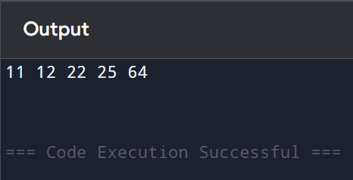
(B)
#include <stdio.h>
void insertionSort(int a[], int n){
for(int i=1; i<n; i++){ // consider element a[i] to insert into sorted left part
int key = a[i]; // value to insert
int j = i - 1;
// shift elements right until correct position for key is found
while(j >= 0 && a[j] > key){
a[j+1] = a[j];
j--;
}
a[j+1] = key; // insert key at its correct position
}
}
int main(){
int a[] = {12, 11, 13, 5, 6};
int n = sizeof(a)/sizeof(a[0]);
insertionSort(a,n);
for(int i=0;i<n;i++) printf("%d ", a[i]);
printf("\n");
return 0;
}
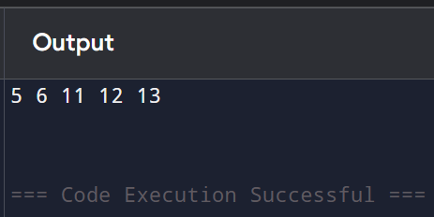

(C)
#include <stdio.h>
void bubbleSort(int a[], int n){
for(int i=0;i<n-1;i++){ // n-1 passes
for(int j=0;j<n-1-i;j++){ // after i passes last i elements are in place
if(a[j] > a[j+1]){ // if out of order, swap adjacent
int t = a[j]; a[j] = a[j+1]; a[j+1] = t;
}
}
}
}
int main(){
int a[] = {5, 1, 4, 2, 8};
int n = sizeof(a)/sizeof(a[0]);
bubbleSort(a,n);
for(int i=0;i<n;i++) printf("%d ", a[i]);
printf("\n");
return 0;
}
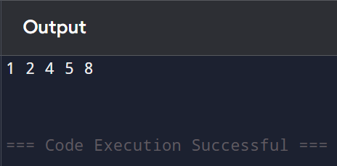

(D)
#include<stdio.h>
void merge(int a[], int l, int m, int r){
int i = l, j = m + 1, k = 0;
int temp[100];
while (i <= m && j <= r)
temp[k++] = (a[i] < a[j]) ? a[i++] : a[j++];
while (i <= m) temp[k++] = a[i++];
while (j <= r) temp[k++] = a[j++];
for (i = l, k = 0; i <= r; i++, k++)
a[i] = temp[k];
}
void mergeSort(int a[], int l, int r){
if (l < r){
int m = (l + r) / 2;
mergeSort(a, l, m);
mergeSort(a, m + 1, r);
merge(a, l, m, r);
}
}
int main(){
int a[100], n;
printf("Enter n: ");
scanf("%d", &n);
printf("Enter elements: ");
for (int i = 0; i < n; i++) scanf("%d", &a[i]);
mergeSort(a, 0, n - 1);
printf("Sorted array: ");
for (int i = 0; i < n; i++) printf("%d ", a[i]);
return 0;
}
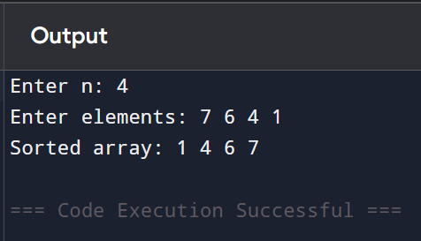

(E)
#include<stdio.h>
int partition(int a[], int l, int r){
int pivot = a[r];
int i = l - 1;
for (int j = l; j < r; j++){
if (a[j] < pivot){
i++;
int temp = a[i]; a[i] = a[j]; a[j] = temp;
}
}
int temp = a[i+1]; a[i+1] = a[r]; a[r] = temp;
return i + 1;
}
void quickSort(int a[], int l, int r){
if (l < r){
int pi = partition(a, l, r);
quickSort(a, l, pi - 1);
quickSort(a, pi + 1, r);
}
}
int main(){
int a[100], n;
printf("Enter n: ");
scanf("%d", &n);
printf("Enter elements: ");
for (int i = 0; i < n; i++) scanf("%d", &a[i]);
quickSort(a, 0, n - 1);
printf("Sorted array: ");
for (int i = 0; i < n; i++) printf("%d ", a[i]);
return 0;
}
